# NEW YORK ARTIST RACHEL LEE HOVNANIAN’S EXHIBITION

***Open Secrets***

# TO OPEN JULY 20, 2019 AT PALAZZO MEDICEO DI SERAVEZZA

Rachel Lee Hovnanian *– Beauty Queen Totem, 2009*

Photo Credit: Nicola Gnesi

**Press Preview:** Thursday July 18, 2019 - Noon

**Vernissage:** Saturday July 20, 6PM - 8PM

SERAVEZZA, ITALY– We are pleased to announce the opening of New York artist **Rachel Lee Hovnanian’s** exhibition ***Open Secrets*** at **Palazzo Mediceo,** a UNESCO World Heritage sitelocated in Seravezza, Italy. The exhibition spans ten years of work from the New York-based contemporary artist and includes 14 works that combine paintings, sculptures, interactive installations, works on paper, and video art. Curated by **Annalisa Bugliani** and organized by **Pechersky Family Foundation** in collaboration with **Galleria Poggiali** and **Fondazione Terre Medicee**, ***Open Secrets*** is the multi-disciplinary artist’s first solo museum show.

With ***Open Secrets***, Hovnanian posits a humanist approach that emphasizes human autonomy within our digital age of addiction to perfection. Much like her previous body of work, ***Open Secrets*** engages with ubiquitous yet nuanced notions of narcissism, obsession and intimacy, and society’s alienating addiction to modern technology.

The exhibition navigates the post-internet world through surreal environments that challenge viewers to examine and reevaluate their own cultural values and relationships with digital technology. It invites them to delve into the embedded societal mores that reveal the dichotomy between our intrinsic value system and our public selves, as seen in *“Perfect Baby Showroom*.”

Highlighting the irony of society’s infatuation with hyper-connectivity and despite all the new digital means of communication, Hovnanian questions if we are connecting as closely with others in this post-internet age. The exhibition brings to light the unspoken pressure on individuals to use these new modes of communication to display their curated lives. In the pursuit of gratification, our increasingly virtual existences have begun to influence and obscure our relationship with reality. ***Open Secrets*** reveals the dual sensibilities that have evolved through the rise of the digital revolution, especially in **Hovnanian’s** newbody of work *“Too Good to be True”,* and her monumental *“Beauty Queen Totem”*, a larger-than-life Carrara marble sculpture of a pageant winner that speaks to the idea that conceptions of beauty in our mediagenic age are codified as touchstones of social power.

*"I conceived this exhibition to initiate complex dialogues on modern relationships with technology”, says* ***Hovnanian****, “I want to challenge viewers to confront the potential future of digital technology, and the role that humanity plays within society’s alienating addiction to modern technology "*

Following the genesis of social media platforms and the ubiquity of smartphones, Hovnanian created *“Dinner for Two”,* an installation of an extravagantly dining table set for supper. Seated at either end are two diners, represented as their likeness on a screen. Rather than looking at each other, the diners spend most of their time gazing at their phones. The installation’s audio plays only digital notification sounds. With her *“Happy Hour”* series, *“House of Empty Bottles”,* and *“Taped Shut”* sculptures, Hovnanian uses her own personal experience of growing up in a household where the effects of addiction were hushed because of society’s pressures towards an image of perfection.

As the rise of digital technology has allowed for great strides in science and in global connectivity, Hovnanian’s video installation *“C.R.E.E.P.S*.” underscores howwe openly offer our personal information in exchange for the opportunity to participate in the digital revolution.

# About Rachel Lee Hovnanian

Born in West Virginia and raised in Houston Texas, Rachel Lee Hovnanian is a New York-based artist whose multidisciplinary practice explores contemporary notions of narcissism, obsession and intimacy, and society’s alienating addiction to media & technological innovations. She navigates the post-internet world, merging photography, video, sculpture, painting and installation art into surreal environments that challenge viewers to examine and re-evaluate their own cultural values and relationship with digital technology. With her 2018 The Women's Trilogy Project, Hovnanian became the first female artist to be given three consecutive gallery exhibitions in New York. Hovnanian received her BFA from the University of Texas, Austin; she has exhibited in both solo and group exhibitions in the United States, Asia, Europe, and the Middle East. Her work is in the collections of private individuals, corporations, and museums, including the Royal Family of Dubai, Lily Safra, the Mallin Collection, the corporate collections of AT&T, Dior, Graff Diamonds and TD Bank, Moscow’s Multimedia Art Museum) and the 21c Museum Hotel. rachelleehovnanian.com | @rachelleehovnanian

**About Palazzo Mediceo**

Located in the historical town of Seravezza in northern Tuscany, Palazzo Mediceo was commissioned in the 16th century by Cosimo de Medici, Grand Duke of Tuscany, as a temporary residence during his visits to the marble quarries and silver mines as well as a military outpost. In 1982, it transitioned into an exhibition space for modern and contemporary art. UNESCO designated the Palazzo and the Medici Garden a World Heritage Site in June 2013. <http://www.palazzomediceo.it> | [@palazzomediceoseravezza](https://www.instagram.com/palazzomediceoseravezza/?hl=en)

**About Pechersky Family Foundation**Founded in 2018, the Pechersky Family Foundation’s mission is to support a diversity of cultural initiatives with a focus on contemporary art, theater and cinema.

In addition to building its own art collection, the Foundation’s aim is to connect and link diverse cultural practices, enriching local context, and reinforcing the presence of Russian art internationally. <http://www.pecherskyfoundation.com/> | [@pecherskyfoundation](https://www.instagram.com/pecherskyfoundation/)

## “Open Secrets” - Rachel Lee Hovnanian

Saturday, July 20, 2019 through Sunday, September 15, 2019

Open daily from 5PM to 11PM

**The Medici Palace Museum**

230, Viale Leonetto Amedei

55047 Seravezza - Lucca Italy

Info: [www.palazzomediceo.it](http://www.palazzomediceo.it/)

# International Press Contact

# [OpenSecrets@NadineJohnson.com](mailto:OpenSecrets@NadineJohnson.com)

# +1 212 228-5555

## 

## This exhibition would not have been possible without the support of our partners:

## Pechersky Family Foundation, Palazzo Mediceo, the town of Seravezza, Fondazione Henraux, Malo Forte dei Marmi, Cassetti, Tenuta del Buonamico, Fondazione Terre Medicee, Alle Boe Beach Club Forte dei Marmi and Bagno Piero.

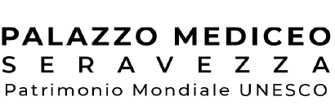 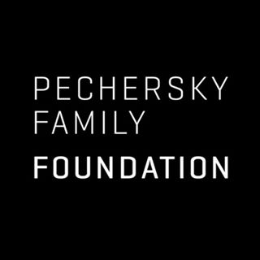 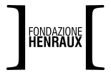

 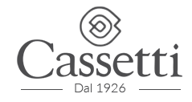

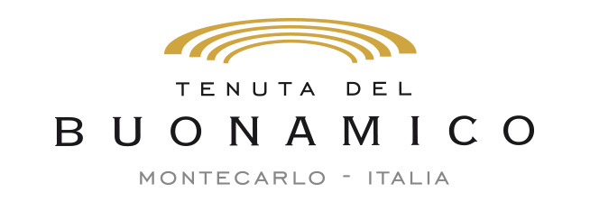 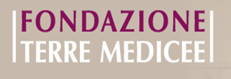

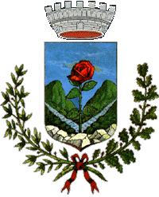 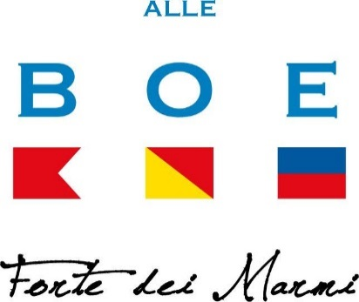

## F:\Public\ART + CULTURE - PUBLIC\2019 CURRENT CLIENTS\PROJECT BASED - RACHEL HOVNANIAN\2019\PRESS MATERIALS\LOGOS\Galleria Poggiali.pngF:\WP\Public\ART + CULTURE - PUBLIC\2019 CURRENT CLIENTS\PROJECT BASED - RACHEL HOVNANIAN\2019\VISUALS\PARTNER LOGOS\Bagno Piero Logo.jpg